# Final Report: Visualizing Housing Market Trends: An Analysis of Sale Prices and Features using Tableau

1. **INTRODUCTION**

## Project Overview

This project focuses on leveraging Tableau to visualize and analyze housing market trends, specifically concerning sale prices and property features. The primary goal is to transform complex real estate datasets into interactive and easily digestible visual insights. This will assist various stakeholders, including homebuyers, investors, and real estate professionals, in making informed decisions by identifying patterns and correlations within the housing market.

## Purpose

The purpose of this project is to provide a comprehensive and intuitive platform for understanding the factors influencing housing sale prices. By visualizing data on property size, amenities, renovation status, and location, the tool aims to demystify real estate market dynamics. This will lead to improved decision-making for buyers and sellers, enable strategic planning for investors and agents, and contribute to greater transparency in the housing market.

# IDEATION PHASE

## Problem Statement

The real estate market is characterized by vast and complex datasets on housing features and sale prices. These datasets are often underutilized due to a lack of effective visualization, making it challenging for buyers, sellers, and analysts to derive insights or forecast trends efficiently.

Customer Pain Points:

|  |  |  |  |  |
| --- | --- | --- | --- | --- |
| I am (Customer) | I'm trying to | But | Because | Which makes me feel |
| A first-time homebuyer who wants to make an  informed  decision | Find a home within my budget that meets my needs | The available market data is difficult to  interpret and  scattered across multiple sources | There is no centralized, easy-to- use tool that visualizes housing trends based on  historical sales data | Confused and overwhelmed, making me  hesitant to proceed |

|  |  |  |  |  |
| --- | --- | --- | --- | --- |
| I am (Customer) | I'm trying to | But | Because | Which makes me feel |
| A real estate investor looking for high-return properties | Identify profitable properties based on price trends and key influencing factors | Existing datasets require  extensive manual analysis and lack clear insights | No interactive visualization tool allows me to compare property appreciation trends effectively | Frustrated and uncertain about making  investment decisions |
| A real estate agent aiming to assist clients efficiently | Provide accurate and insightful  recommendations based on market data | The data is time- consuming to  analyze and  spread across various reports | There is no comprehensive tool to aggregate and visualize pricing trends for quick insights | Less efficient, unable to provide quick, data-backed advice to clients |

Core Problem Question: How can housing sale price trends and property characteristics be visualized and analyzed using Tableau to identify patterns, improve buyer/seller decision-making, and uncover insights that support strategic real estate planning?

## Empathy Map Canvas

The empathy map visually captures user behaviors and attitudes, aiding in understanding the true problem from the user's perspective, their goals, and challenges.

* + - Think & Feel: Users are concerned about market fluctuations and whether they are making data-driven conclusions.
    - See: Users see charts and graphs in Tableau, as well as the latest data on sale prices.
    - Say & Do: Users share findings with their team and compare property attributes.
    - Hear: Users engage in discussions with colleagues and stay updated with market news and reports.

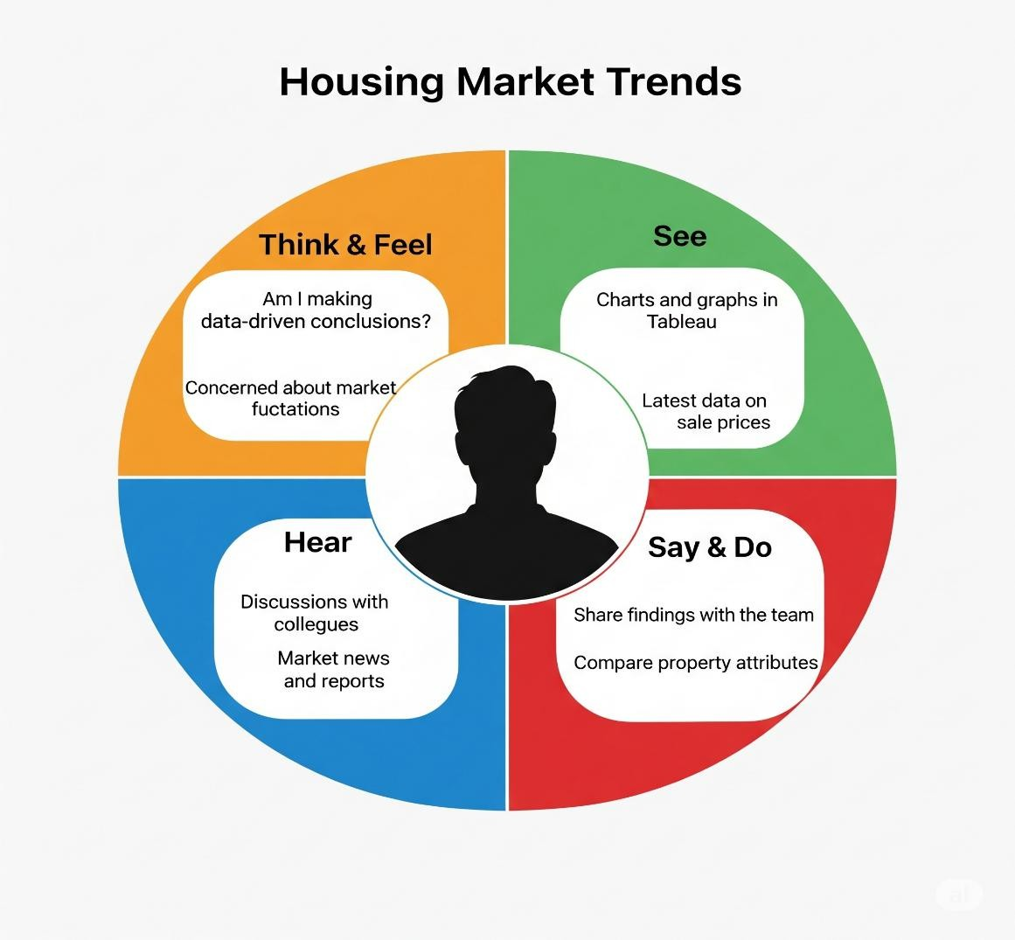

## Brainstorming

The brainstorming session involved team collaboration to identify pressing challenges in the real estate market, particularly focusing on how property features influence housing sale prices. The objective was to visually explore trends using Tableau to help various stakeholders understand patterns of sale prices based on features like area, bedrooms, renovation status, condition, and location (zipcode groups).

Idea Listing and Grouping:

|  |  |  |
| --- | --- | --- |
| S.No | Idea Description | Category |
| 1 | Visualize average sale price by SalePriceBin | Pricing Insights |
| 2 | Analyze impact of number of bedrooms on sale price | Property Features |
| 3 | Explore relationship between Total Area and Price (scatter plot) | Size-Based Pricing |
| 4 | Compare prices for renovated vs. non-renovated homes | Renovation Analysis |
| 5 | Group insights by Zipcode Clusters | Geographical Comparison |
| 6 | Analyze house condition vs. price using dummy variables | Quality-Based Pricing |

|  |  |  |
| --- | --- | --- |
| S.No | Idea Description | Category |
| 7 | Add calculated field: TotalAreaSqft | Data Preparation |
| 8 | Create SalePriceBin with 100k intervals | Binning / Categorization |
| 9 | Use Tableau dashboard to combine insights | Dashboard Design |
| 10 | Build a Story in Tableau for narrative | Storytelling & Reporting |
| 11 | Embed Dashboard in Web Application using Flask | Deployment & Integration |
| 12 | Add filters for Bedrooms, Condition, Renovation in Dashboard | Interactive Exploration |

Idea Prioritization Table:

|  |  |  |  |  |
| --- | --- | --- | --- | --- |
| S.No | Idea Description | Impact | Feasibility | Priority |
| 1 | Visualize average sale price by SalePriceBin | High | Easy | High |
| 2 | Analyze impact of number of bedrooms on sale price | High | Easy | High |
| 3 | Explore TotalArea vs Price (scatter plot) | High | Easy | High |
| 4 | Compare prices for renovated vs. non-renovated homes | High | Medium | High |
| 5 | Group insights by Zipcode Clusters | Medium | Medium | Medium |
| 6 | Analyze house condition vs. price | High | Medium | High |
| 7 | Add calculated field: TotalAreaSqft | Medium | Easy | High |
| 8 | Create SalePriceBin with 100k intervals | Medium | Easy | High |
| 9 | Use Tableau dashboard to combine insights | High | Easy | High |
| 10 | Build a Story in Tableau | High | Medium | High |
| 11 | Embed Dashboard in Web Application | High | Hard | Medium |
| 12 | Add filters for Bedrooms, Condition, Renovation | Medium | Easy | Medium |

# REQUIREMENT ANALYSIS

## Customer Journey Map

The customer journey map outlines the user's experience across various stages of interacting with the housing market trends dashboard.

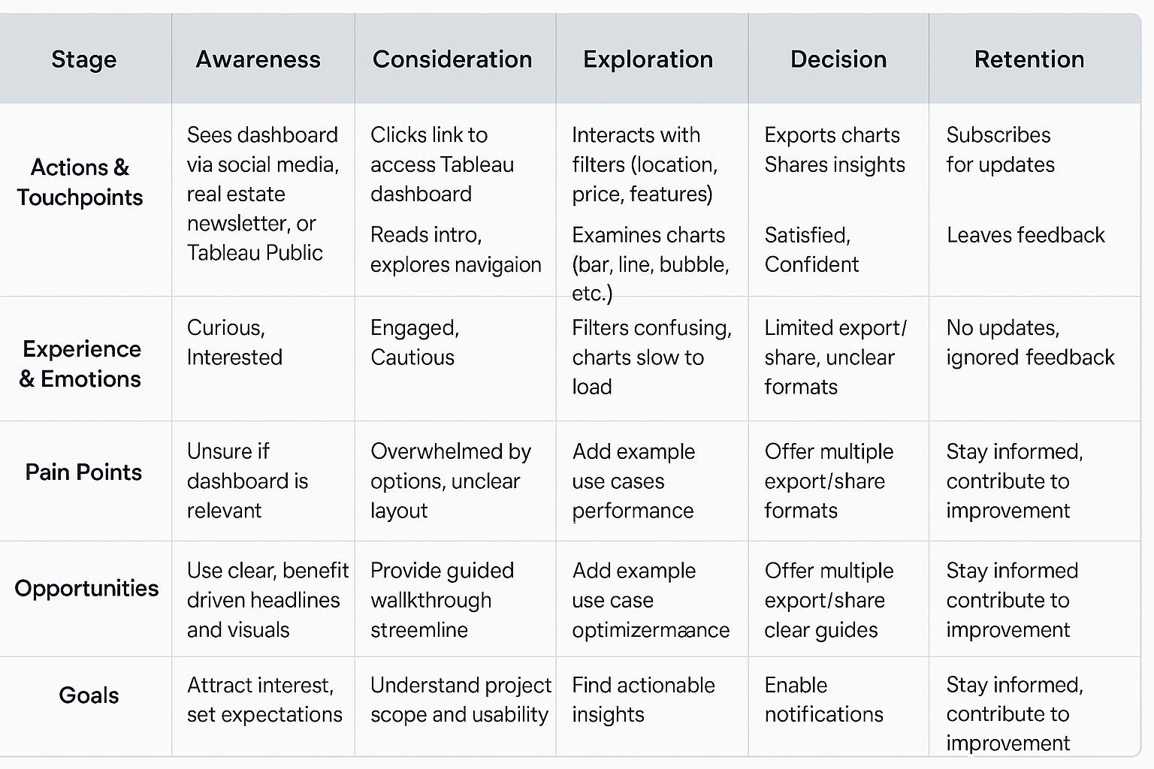

* 1. **Solution Requirement**

**Functional Requirements (FR):**

|  |  |  |
| --- | --- | --- |
| FR  No. | Functional Requirement (Epic) | Sub Requirement (Story / Sub-Task) |
| FR-1 | Data Import | * Import data from CSV * Live database integration (e.g., MySQL, if applicable) |
| FR-2 | Data Cleaning & Transformation | * Clean missing values * Add calculated fields (e.g., TotalAreaSqft, SalePriceBin) |
| FR-3 | Data Visualization | * Create Tableau worksheets * Build multiple interactive dashboards |
| FR-4 | User Interaction | * Filter by location, price range, features (e.g., bedrooms, condition, renovation) * Comparative charts (bar, scatter, etc.) |
| FR-5 | User Access | * Role-based views (Homebuyer, Investor, Agent, Analyst) * Download/export insights (PDF/image) |

|  |  |  |
| --- | --- | --- |
| FR  No. | Functional Requirement (Epic) | Sub Requirement (Story / Sub-Task) |
| FR-6 | Feedback Loop | * Stakeholder review & feedback * Implement iterative revision cycles |

**Non-functional Requirements (NFR):**

|  |  |  |
| --- | --- | --- |
| NFR  No. | Non-Functional Requirement | Description |
| NFR-1 | Usability | Intuitive UI with clear filters, legends, and navigation for all users |
| NFR-2 | Security | Role-based access control; secure database connection |
| NFR-3 | Reliability | Handles malformed data smoothly; ensures visualization and calculation accuracy |
| NFR-4 | Performance | Fast loading and responsive visualizations, even with large datasets |
| NFR-5 | Availability | Accessible on desktops, tablets, mobiles; minimal downtime |
| NFR-6 | Scalability | Supports future data growth and feature expansions |

* 1. **Data Flow Diagram**

The data flow for this project would involve:

1. Data Ingestion: Raw housing data (e.g., from CSVs or databases).
2. Data Transformation: Python scripts for cleaning, feature engineering (e.g., TotalAreaSqft, SalePriceBin).
3. Data Storage: Optionally, storing processed data in a structured database (e.g., MySQL).
4. Data Visualization: Tableau connecting to the processed data to create dashboards and stories.
5. Web Deployment: A Flask application serving the Tableau visualizations to end-users via a web browser.

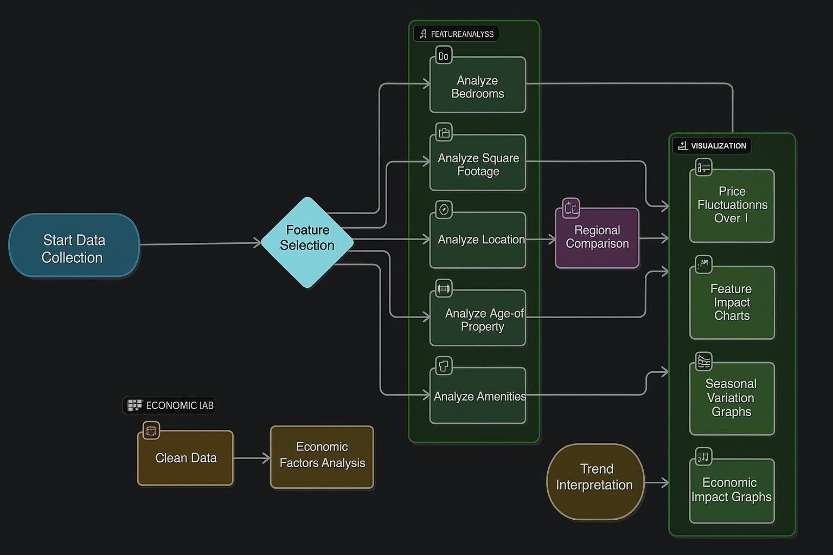

## Technology Stack

The comprehensive technology stack involves various components for data sources, processing, analytics, and visualization.

The technology stack for this project includes:

* + - Data Sources: User Uploaded Sale Data, Public Real Estate Listings, News Feeds, Government Property Records, Third-Party Market Reports, Social Media Feeds.
    - Data Ingestion and Processing: Mechanisms to process raw data from various sources.
    - Data Storage: Solutions for storing processed data.
    - Analytics and Modeling:
      * Cluster Analysis
      * Time Series Analysis
      * Predictive Modeling
      * Comparative Feature Analysis
      * Geographic Mapping
    - Visualization Layer: Connects analytics to user groups, primarily driven by Tableau.
    - User Groups: Real Estate Agents, Home Buyers and Sellers, Market Analysts, Urban Planners, Public and Media.

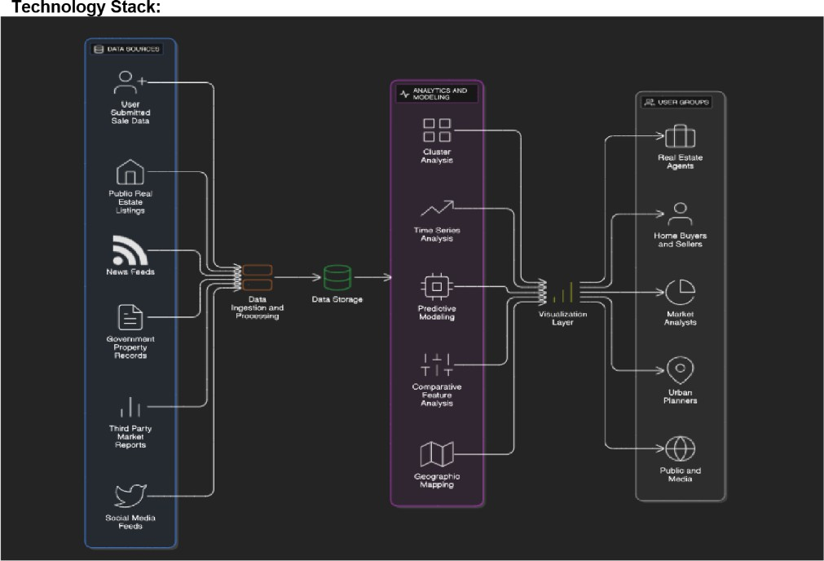

# PROJECT DESIGN

## Problem Solution Fit

The solution directly addresses the identified problem of complex and underutilized housing market data by providing interactive, insightful visualizations. It bridges the gap between raw data and actionable insights, enabling stakeholders to make data-driven decisions. The fit is achieved by offering a user-friendly interface that simplifies the exploration of trends influenced by property features and location, thereby resolving the pain points of scattered and difficult-to-interpret information.

## Proposed Solution

Our solution transforms static housing datasets into interactive, insightful visualizations using Tableau. The project involves cleaning and transforming the data, creating calculated fields and Key Performance Indicators (KPIs), and developing a dashboard that highlights key trends, comparisons, and location-based analyses. The solution is optionally deployed via a Flask web application for broader accessibility.

|  |  |  |
| --- | --- | --- |
| S.No. | Parameter | Description |
| 1 | Problem  Statement | The real estate market involves vast and complex datasets on housing features and sale prices. These datasets are often underutilized due to lack of effective visualization, making it difficult for buyers, sellers, and analysts to draw insights or forecast trends. |
| 2 | Idea / Solution  Description | Our solution transforms static housing datasets into interactive, insightful  visualizations using Tableau. The project involves cleaning and transforming |

|  |  |  |
| --- | --- | --- |
| S.No. | Parameter | Description |
|  |  | the data, creating calculated fields and KPIs, and developing a dashboard that highlights key trends, comparisons, and location-based analyses. The solution is deployed via a Flask web app. |
| 3 | Novelty / Uniqueness | This project leverages Tableau's powerful visual capabilities to go beyond basic data analytics. By combining calculated fields, condition segmentation, and geographic mapping, the dashboard offers a dynamic exploration of how features like bedrooms, area, renovation, and location influence housing prices. |
| 4 | Social Impact / Customer Satisfaction | This solution enables real estate buyers, sellers, agents, and market researchers to make informed decisions. It improves housing transparency, supports better urban planning, and enhances user engagement with clear visuals and actionable insights. |
| 5 | Business Model (Revenue  Model) | This dashboard can be scaled and offered as a subscription-based SaaS tool to real estate companies, market research firms, or housing consultancies. Advanced forecasting modules, API integrations, and custom dashboards can be monetized as premium features. |
| 6 | Scalability of the Solution | The system is designed to be scalable and adaptable. It can incorporate new datasets (like rental trends or economic indicators), extend to new regions or cities, and integrate with ML models for price predictions, thereby offering long-term growth potential. |

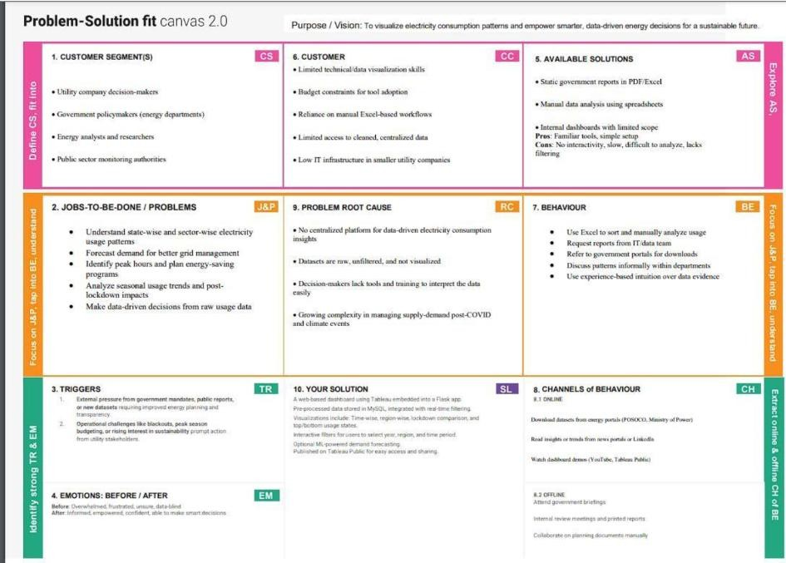

## Solution Architecture

The solution architecture is designed for efficient data processing, visualization, and web deployment. The solution begins with users uploading real estate data in CSV format, which is cleaned and transformed using Python. The processed data is optionally stored in a MySQL database managed through MySQL Workbench. Tableau Public connects to this structured data to create dynamic dashboards for visual analysis. A Flask web application, styled with HTML and CSS, hosts these dashboards on the web. End users access the platform via a browser to explore trends, filter data, and gain actionable insights.

* + - User Interaction: Users input CSV data.
    - Data Processing: Python script for cleaning and transformation.
    - Data Storage: Optional MySQL database via Workbench.
    - Visualization: Tableau Public for dashboard creation.
    - Web Deployment: Flask web application with HTML/CSS.
    - End User Access: Users interact via a web browser.

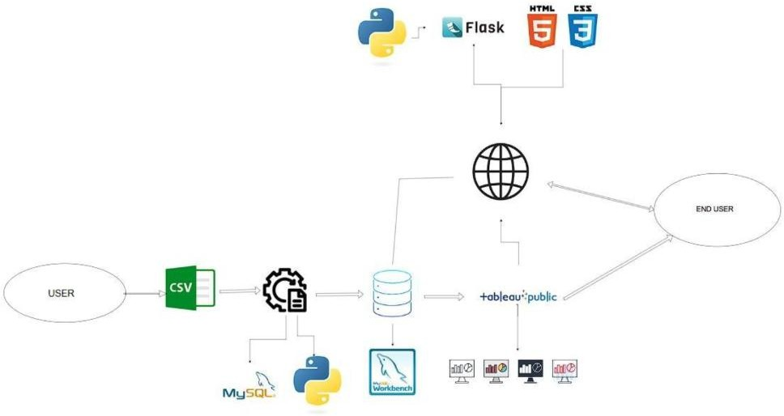

# PROJECT PLANNING & SCHEDULING

## Project Planning

The project planning outlines the key phases and activities involved in the development of the solution. Project Phases:

* + - Ideation Phase:
      * Define the Problem Statements
      * Empathize & Discover (Empathy Map)
      * Brainstorm & Idea Prioritization
    - Project Design Phase-II:
      * Technology Stack (Architecture & Stack)
      * Solution Requirements (Functional & Non-functional)
      * Data Flow Diagram & User Stories
      * Proposed Solution
      * Solution Architecture
      * Problem – Solution Fit

|  |  |  |  |  |  |  |
| --- | --- | --- | --- | --- | --- | --- |
| Sprint | Functional Requirement (Epic) | User Story Number | User Story / Task | Story Points | Priority | Team Members |
| Sprint- 1 | Data Acquisition & Preparation | USN-1 | As a data analyst, I can identify and acquire relevant housing market datasets (e.g., sale prices, property features, location data) so that I have the raw material for analysis. | 3 | High | Borra Jaswanth Kumar |
| Sprint- 1 | Data Acquisition & Preparation | USN-2 | As a data analyst, I can clean and preprocess the acquired datasets (handle missing values, correct  inconsistencies) so that the data is ready for Tableau. | 5 | High | Chinta Divya |
| Sprint- 1 | Initial Visualization Setup | USN-3 | As a Tableau user, I can connect Tableau to the cleaned dataset so that I can start building visualizations. | 2 | High | Gudi Maruthi |
| Sprint- 2 | Core Visualizations | USN-4 | As a data analyst, I can create a scatter plot showing sale price vs. square footage so that I can identify basic correlations. | 3 | Medium | Borra  Hemanth |

# FUNCTIONAL AND PERFORMANCE TESTING

## Performance Testing

The performance testing phase was designed to ensure that the Tableau dashboards and the Flask web application provide fast loading and responsive visualizations, even when handling large datasets. This directly addresses the NFR-4 (Performance) requirement. Key metrics for performance testing would include dashboard load times, filter application speed, and overall responsiveness of the user interface.

The performance testing methodology included the following stages:

* + - Stage 1: Data Collection & Understanding
      * Actions & Tools: Review dataset fields (Sale_Price, Bedrooms, Bathrooms, Area, Renovation info, Zipcode Groups, etc.); Clean and format in Excel/MySQL.
      * Objectives: Ensure data quality, understand variable significance.
    - Stage 2: Data Preprocessing
      * Actions & Tools: Bin numerical features (e.g., Price, Age of House); Create calculated fields (e.g., Price per Sqft, Renovated Status); Derive meaningful groupings (e.g., Zipcode_Group).
      * Objectives: Enable intuitive filtering, meaningful comparisons.
    - Stage 3: Dashboard Planning
      * Actions & Tools: Sketch layout (filters on side/top, charts in grid); Map visuals to questions (e.g., "Which areas have the highest renovated house prices?").
      * Objectives: Define clear goals and user flow.
    - Stage 4: Visualization Building in Tableau
      * Actions & Tools: Use bar/line charts for trend over time; Bubble/map views for geographic distribution; Filters: Zipcode, Features, Renovation.
      * Objectives: Communicate patterns, spatial insights.
    - Stage 5: Story Integration
      * Actions & Tools: Create Tableau Story to guide users: from Overview → Deep Dive → Insights; Add captions to explain visual intent.
      * Objectives: Enhance narrative, support user understanding.
    - Stage 6: Performance Testing
      * Actions & Tools: Test responsiveness, filter logic; Ensure tooltips and legends work; Optimize load times.
      * Objectives: Maximize usability and engagement.
    - Stage 7: Export & Feedback
      * Actions & Tools: Enable export features (PNG, PDF, share link); Add feedback prompts or embed survey links.
      * Objectives: Promote shareability, gather improvement input.

# RESULTS

## Output Screenshots

The implementation involved data cleaning and transformation using Python, followed by the creation of interactive visualizations in Tableau. The key outputs are the Tableau Dashboards and the Tableau Story, which provide comprehensive insights into housing market trends.

* + - Dashboard: Comprehensive House Price Analysis
    - Story: A narrative flow guiding users through key insights.

Dashboard

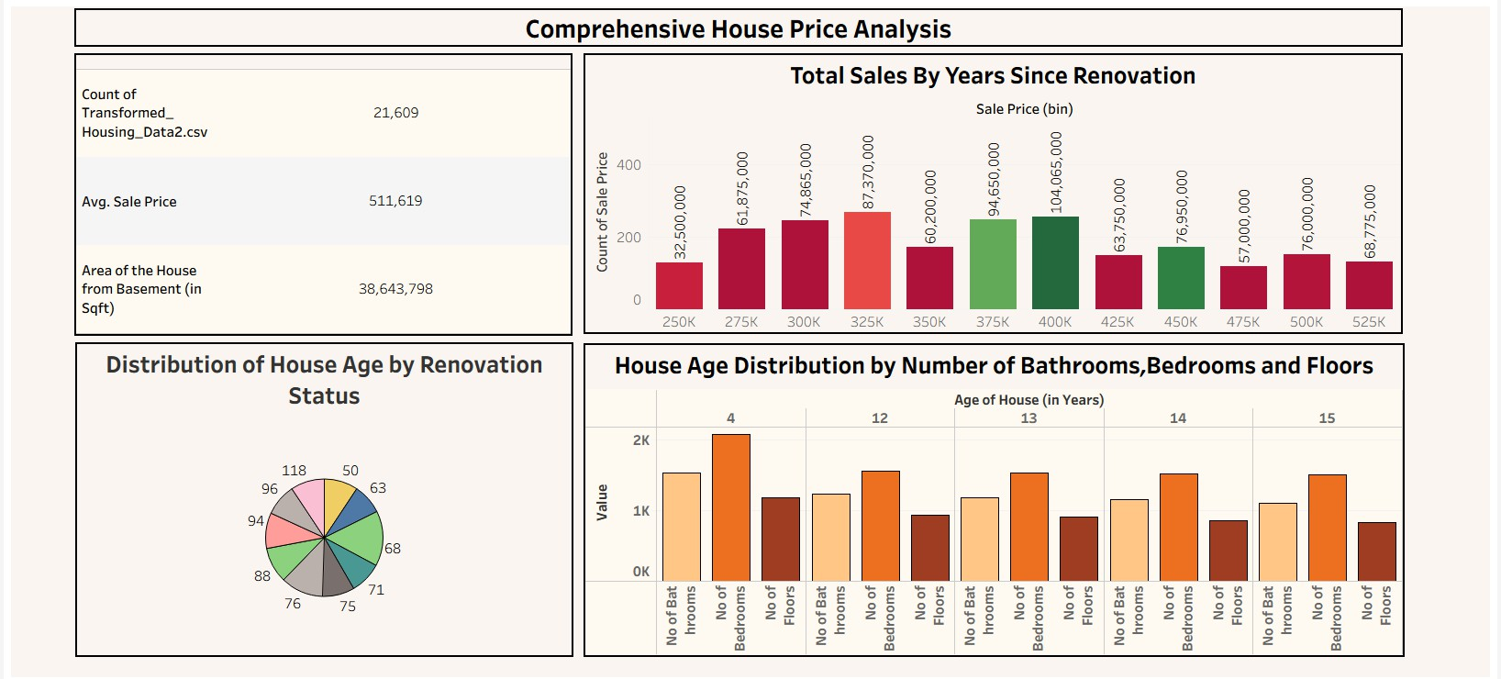

Story

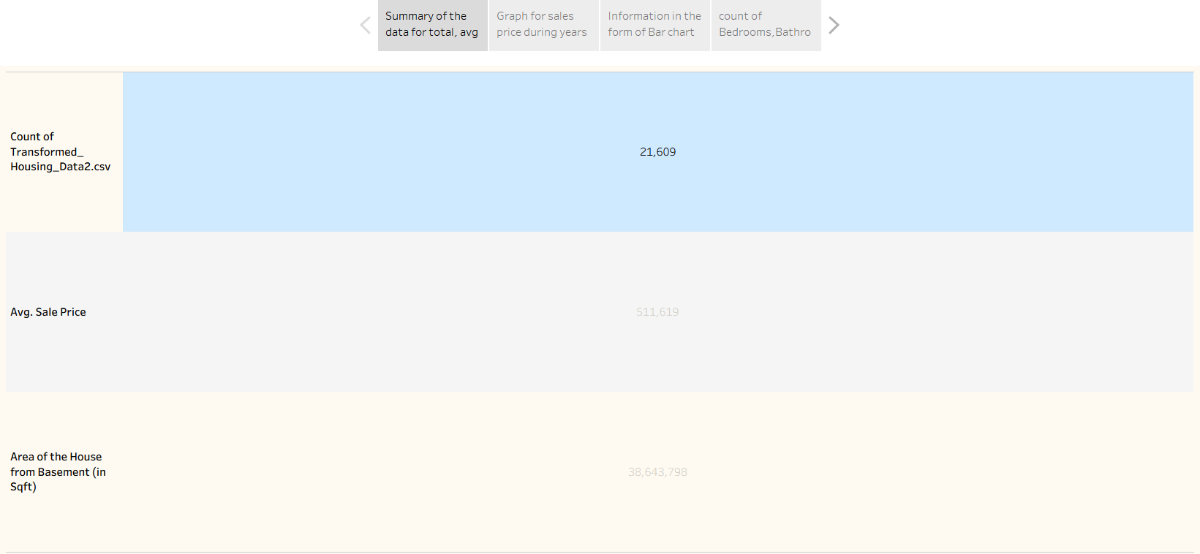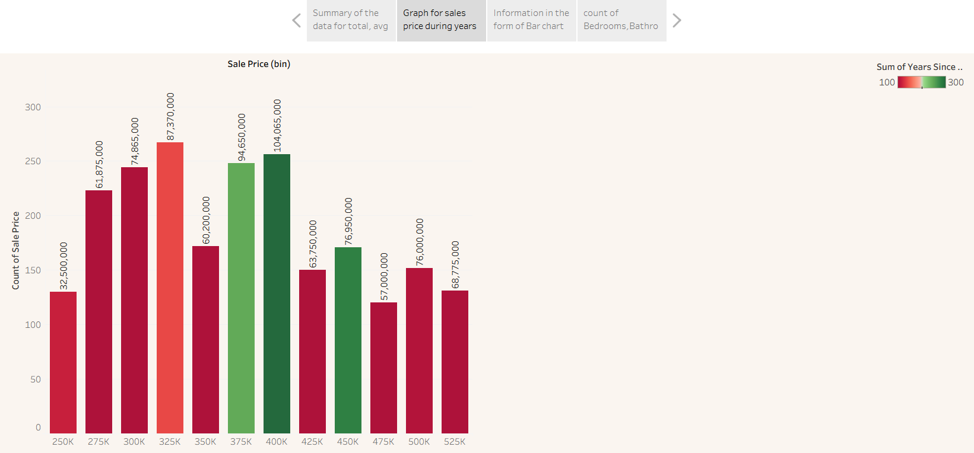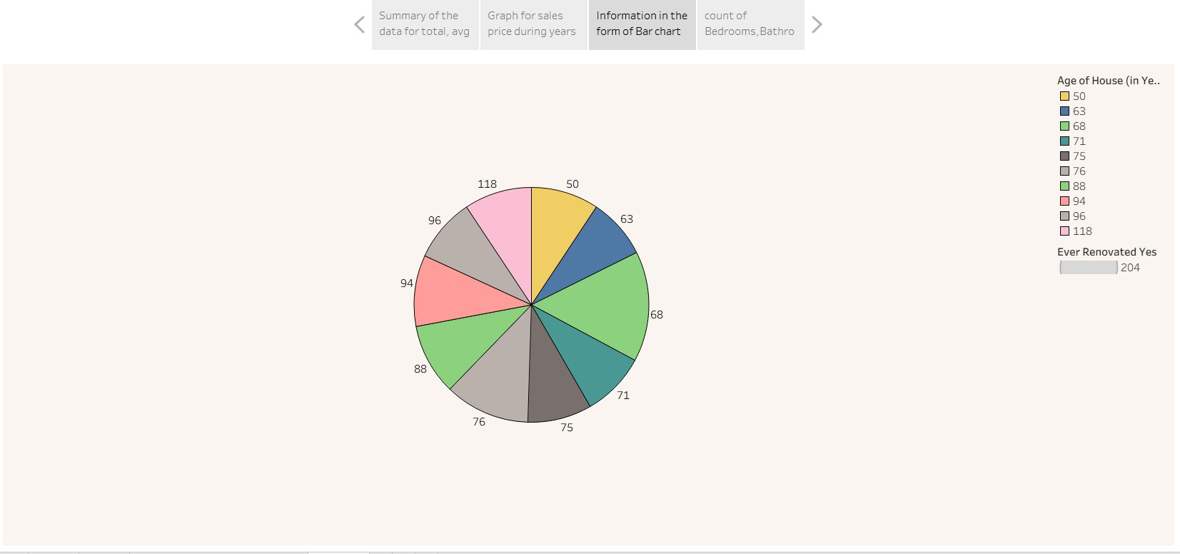

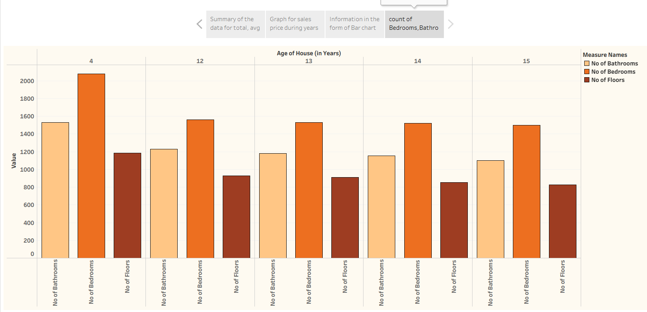

# ADVANTAGES & DISADVANTAGES

## Advantages:

* Enhanced Decision-Making: Provides clear, actionable insights for homebuyers, investors, and real estate professionals.
* Improved Transparency: Simplifies complex real estate data, making market trends accessible to a wider audience.
* Interactive Exploration: Users can dynamically filter and analyze data based on various features (e.g., bedrooms, area, renovation, location).
* Scalability: Designed to incorporate new datasets, extend to new regions, and integrate with advanced analytics (e.g., ML models).
* Data-Driven Insights: Moves beyond traditional reports to provide evidence-based understanding of market dynamics.
* User Engagement: Utilizes intuitive visualizations to enhance user interaction and comprehension.

## Disadvantages:

* Data Dependency: The accuracy and depth of insights are highly dependent on the quality and availability of raw input data.
* Tableau Public Limitations: Reliance on Tableau Public might limit certain advanced features or require an enterprise license for full functionality and private deployment.
* Initial Setup Complexity: Initial data cleaning, transformation, and dashboard design require significant effort and expertise.
* No Direct Forecasting (Current Version): While capable of historical analysis, the current implementation does not include advanced predictive modeling for future price trends without further integration.
* Maintenance: Requires ongoing maintenance for data updates and visualization adjustments as market conditions change.

# CONCLUSION

This project successfully developed an interactive Tableau-based solution for visualizing housing market trends. By transforming complex real estate datasets into clear, actionable insights, the solution empowers various stakeholders, including homebuyers, investors, and real estate professionals, to make informed decisions. The project effectively addressed the pain points of difficult-to-interpret and scattered data by providing a centralized, easy-to-use visualization tool.

The solution's novelty lies in its dynamic exploration of how features like bedrooms, area, renovation status, and location influence housing prices, leveraging Tableau's advanced capabilities. The robust architecture supports data import, cleaning, transformation, and visualization, deployed through a Flask web application for broader accessibility. The identified functional and non-functional requirements ensure a usable, secure, reliable, performant, available, and scalable system.

# FUTURE SCOPE

The system is designed to be scalable and adaptable, offering significant potential for future enhancements:

* New Datasets Integration: Incorporate additional datasets, such as rental trends or broader economic indicators, to enrich the analysis.
* Geographic Expansion: Extend the solution to cover new regions or cities, making it a more comprehensive tool for diverse markets.
* Machine Learning Integration: Integrate machine learning models for advanced price predictions and forecasting modules, offering premium features.
* API Integrations: Develop APIs for seamless integration with other real estate platforms or data sources.
* Custom Dashboards: Offer custom dashboard creation as a monetized premium feature for specific client needs.
* Enhanced User Feedback Loop: Implement more structured mechanisms for stakeholder review and iterative revision cycles to continuously improve the solution.

1. **APPENDIX**

Dataset Link

The project utilized a transformed housing dataset.

* Transformed_Housing_Data2.csv

(https://[www.kaggle.com/datasets/rituparnaghosh18/transformed-housing-data-2)](http://www.kaggle.com/datasets/rituparnaghosh18/transformed-housing-data-2)) GitHub & Project Demo Link

The Tableau dashboards and story are publicly accessible.

* Tableau Public Link for Dashboard and Story:
  + [Comprehensive House Price Analysis Dashboard](https://www.google.com/search?q=https%3A//public.tableau.com/app/profile/divya.chinta4045/viz/FinalTablue_17513064523000/ComprehensiveHousePriceAnalysisDashboard%3Fpublish%3Dyes)
  + [Tableau Story](https://www.google.com/search?q=https%3A//public.tableau.com/app/profile/divya.chinta4045/viz/FinalTablue_17513064523000/Story1%3Fpublish%3Dyes)